


Workday Job Aid
for Employees
Entering and Submitting Time

January 2026

Job Aid: Entering and Submitting Time in Workday
1. Accessing Time Entry
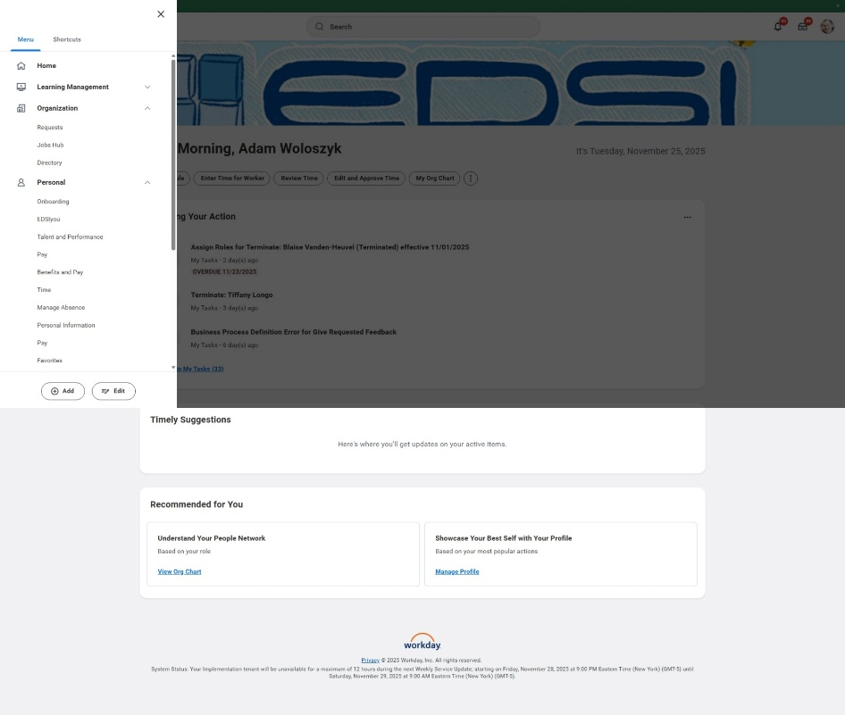
- Click Menu → Time.

2. Method 1: Enter Time by Day
- Click on the day you want to enter time for.
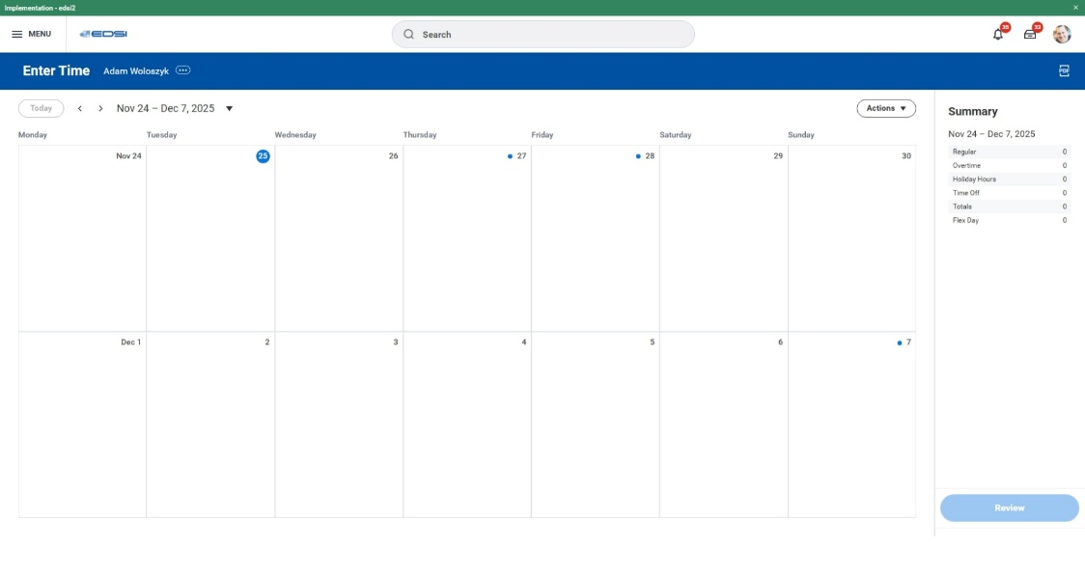

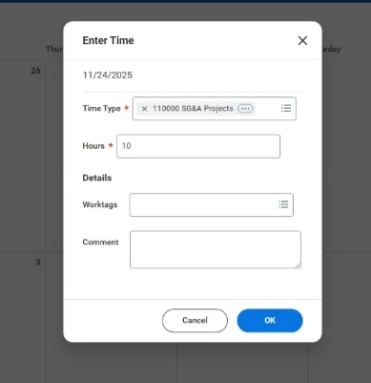
- In the pop‐up:
  - Select Time Type → choose your project code.
  - Enter your hours worked (e.g., 10 hours for a Flex week).
- Click OK.
- ✅ Time entered for one day.

3. Method 2: Quick Add
- Click Actions → Quick Add. | 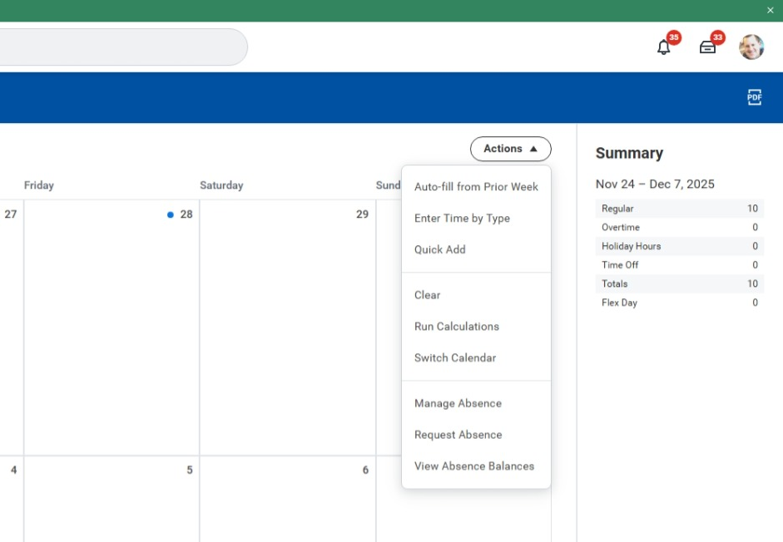
- Select the first week in the pay period.  - Click Next. | 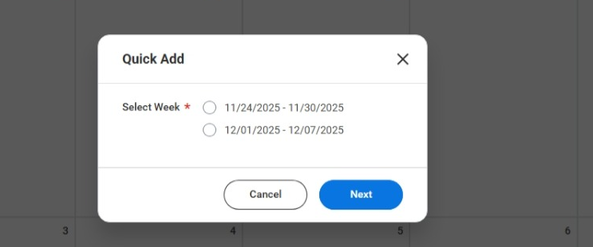
- In Time Type, choose your project code.  - Click Next. | 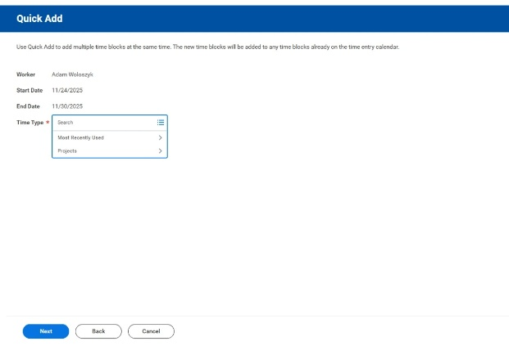
- Enter hours worked (e.g., 10 hours for Tuesday and Wednesday).  - Click OK. | 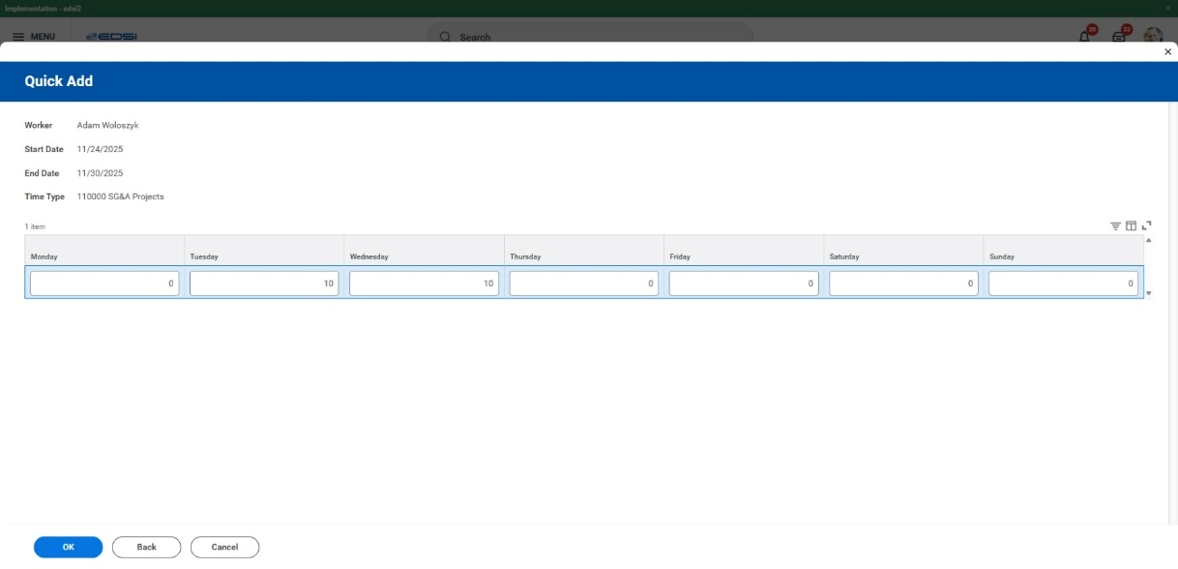

Adding a Holiday
- Click on the holiday day. | 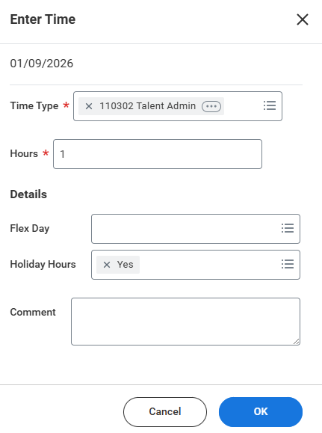
- Choose your project code.

- Enter your hours.

- Under Details, select Holiday Hours → Yes.

- Click OK.
Adding a Flex Day
- Click on your Flex day. | 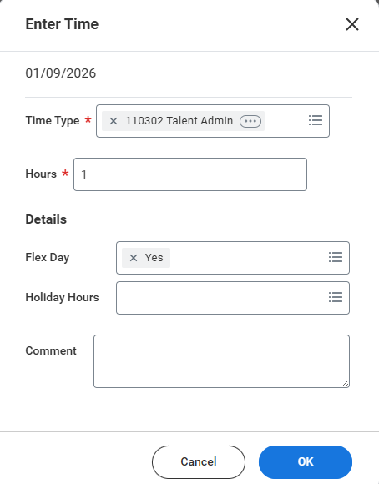
- Choose your project code.

- Enter 1 in the hours field.

- Under Details, select Flex Day → Yes.

- Click OK.
Note: Flex days are always entered as 1 day.
4. Method 3: Enter Time by Type
- Click Actions → Enter Time By Type. | 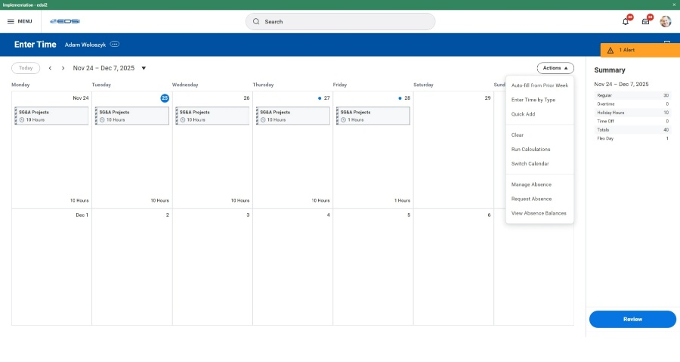
- Select the second week in the pay period.  - Click Next. | 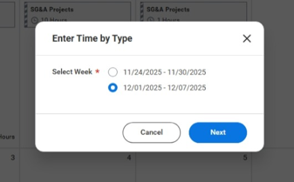
- In Time Type, choose your project code. | 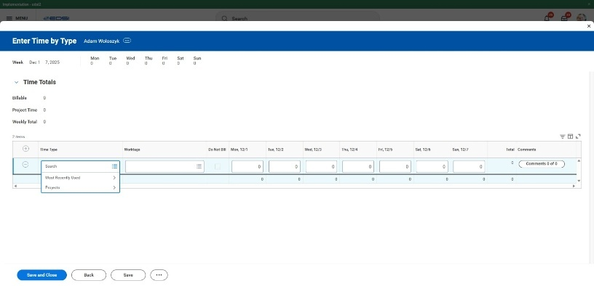
- Enter hours for each day (e.g.,  8 hours/day for a non‐Flex week).  - Click Save and Close. | 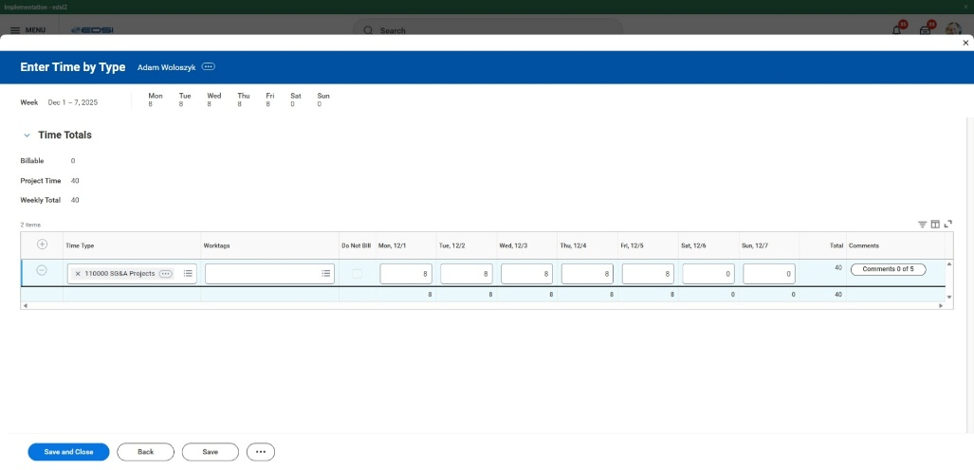

5. Review and Submit
- Click Review  (at the bottom of Summary). | 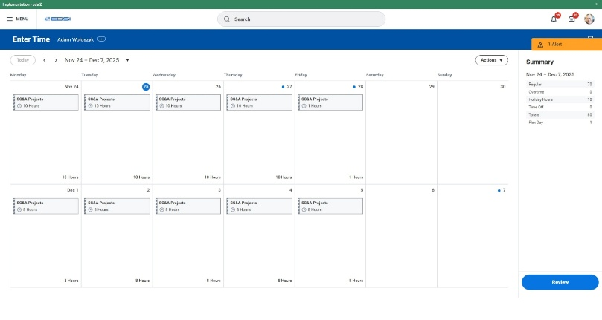
- If there are alerts:
- Click View All to check details.  - Example: Workday may flag a holiday. Confirm your entry is correct.  - When finished,  click Submit. | 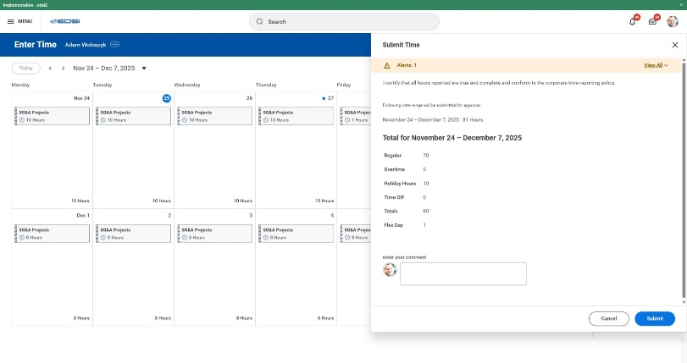
- ✅ Timesheet is sent to your manager.

📌 Key Reminders
- Flex weeks = 10 hours/day + 1 Flex Day.
- Non‐Flex weeks = 8 hours/day.
- Always check alerts before submitting.
- Select options under Details for Holidays and Flex Days.

